**UPI (Unified Payments Interface)**

What is UPI?

**Unified Payments Interface** (UPI) is an instant real-time payments system developed by National Payments Corporation of India facilitating inter-bank transactions. The interface is regulated by the Reserve Bank Of India and works by instantly transferring funds between two bank accounts on a mobile platform.

**Advantages of using UPI**

**1. Cheapest Way of Money Transfer**

The UPI is the cheapest method of fund transfer. The NEFT charges minimum Rs 2.5 for a transfer, the IMPS CHARGES minimum Rs 2.5. But the UPI CHARGES too less to believe. It costs less than 50 paise for a transaction through the UPI.

Because of this low cost, the UPI has the potential to promote the non cash transactions of small amounts.

**2. It Makes you Free from Cash**

There are many ways of transactions which has decreased the cash transactions. The card payment, net banking and mobile wallets are widely used. However, we rarely use the card or netbanking for  small transactions such as payment to your neighborhood grocery or payment to a vegetable vendor. In fact, it is not feasible for the consumer as well as the shopkeeper.

**3. No Need to Give Details**

Most of us avoid using online transaction and card payment because it ask for the bank account details. For card transaction, you give card number, validity period and CVV number. Whereas net banking transaction expose your bank account details. For this reason, the card and online payment is not as much popular. People still prefer cash.

But the UPI solves this problem. The payment through the UPI does not require the card details or bank account details. You have to only give the virtual payment address. the virtual payment address is similar to our email ID. e. g Ramesh45@icicibank, 9876543210@axis. It is easy to remember this ID.

**4. More Secure**

Not everyone uses the card for payment. Not everyone uses the netbanking for the online payment. People are reluctant to use the non cash methods because of the security concern.

What if someone overlooks your PIN while you punch it at the POS terminal. What if the website steal your credit card data and use it for the international transaction.

The UPI has minimized this concern. Actually It is more secure than the present mode of transaction. In the transaction through the UPI, you never share you bank account details. You do not enter your credit card number or CVV. You only give a virtual payment address which does not give any clue about your bank account.

Also the authentication takes place at your smartphone. It is done by punching the two different PINs. You can easily make it discrete while typing at your smartphone.

**5. Instant Transfer**

The UPI is based on IMPS PLATFORM. Thus It works 24 x7. You can make payment any time. There is no restriction of holiday or odd hours. The bank strike will also not affect the UPI payments.

**6. One UPI App Many Accounts**

After the UPI mobile app, you do not need multiple apps for multiple bank account. A single UPI would serve for many bank accounts. You can link many bank accounts in a UPI based app.

**7. Avail COD Without Paying Cash**

We love online shopping till it does not ask money upfront. That is why 80% people opt for cash on delivery. The apprehension is simple, what if I do not get delivery. What if I get a packet of stone instead of the mobile phone. So, why take risks, go for the cash on delivery.

However, sometimes, you don’t have enough cash at your home. If it is a big purchase, you have to rush to the ATM before the delivery boy comes. The UPI ends this hassle.

You can go for the cash on delivery but you are not required to keep cash at your home. You can pay it instantly using the UPI fund transfer.

The Online seller would use the fund collection facility of UPI. Subsequently, You would get a message for the payment approval. You can hold the approval till the delivery. As you get the product, Approve the payment. The delivery boy would get the message immediately of the payment. The cash on delivery is done without using the cash. In actual sense, It is pay on delivery.

**8. Cheaper Alternative of POS Machine**

It is difficult to pay through the card in small  cities. Most of the merchants don’t have the card swiping machine. Let me tell you that this machine is called as the POS terminal.

So, small merchant don’t keep POS terminal because it is costly. They have to pay for the machine. Along with this they have to pay the service charge for each transaction. It varies from 1.25% to 2.5% of the transaction value.

You would have also faced the situation when vendor ask the service charge from you. It happens in a competitive market. In fact keeping POS terminal is not very beneficial for small traders. But, UPI would do the same work with negligible cost. AS UPI operates through the smartphone, anyone can collect money without spending for the machine. Also, the transaction cost is mere 50 paise, It is very low compared to the POS terminal.

**Statistics on UPI**

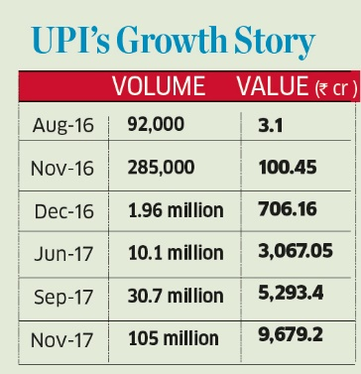

**Why UPI is growing fastly?**

The UPI was launched in April 2016. Digital transactions across platforms such as UPI, m-wallets and debit or credit cards increased multifold after the government in November 2016 scrapped high-denomination notes amounting to 86 percent of all currency in circulation.

Private lenders, according to Morgan Stanley, are expected to be the biggest beneficiaries of the growth in UPI payments. The investment bank, in a note dated May 29, said the platform will help banks deliver and recollect loans at a low cost to borrowers. It expects a 400-500 basis point improvement in the cost income ratio over five to six years for banks.

“Given UPI’s robust, real-time framework, its share in digital transactions is expected to grow exponentially,” Ritesh Saxena, business head in retail banking, digital and payments domain at IndusInd Bank, told BloombergQuint in an email. “A lot of the current usage is P2P (peer-to-peer)-based and consequently lower in ticket sizes, but with more merchant transactions across retail industries, UPI transaction values are going to rise even faster than volumes.”

**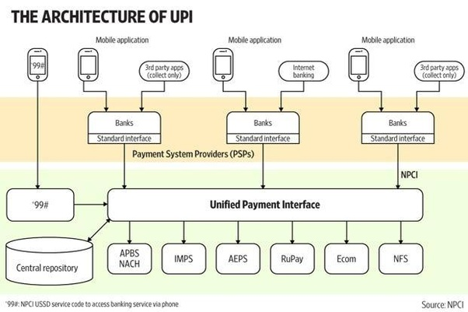      Technology behind UPI**

There are 5 main levels to the UPI architecture.

**Level 0:**

People who build the UPI switch. A switch handles authentication and communication between the issuing and acquiring banks. ‘Generation Two’ switches were card machines on the merchants’ premises; authentication was handled by the machine and the bank customers’ private PIN was keyed into the merchant’s machine, and needed an expensive leased line to operate. ‘Generation Three’ switches are UPI ones—they enable customers to key in PIN/OTP (one-time password) on his/her smartphone, while authentication happens centrally. One big worry is how to get banks to agree to connect to the switch.

**Level 1:**

Those who connect to the switch. In UPI’s case, they are called PSPs. (Old players were called Payment Gateways but these are now passe.) There will be many PSP builders—some inside banks, many outside as start-ups and merchants.

Banks and customers are free to engage with multiple PSPs. The bank may have costs associated each time, while customers will only need to note down different addresses that will be associated with their identities on different PSPs.

**Level 2:**

They connect to the UPI PSP, Visa/Master Card networks, RuPay or International payment gateways. They have to manage the user experience from the card to transaction completion.

**Level 3:**

They are called on-boarders. They have to sign up new UPI, or new wallet, customers. On-boarding has high failure rates and lots of clever hacks go into making that less painful.

**Level 4:**

They are the application guys. They bring new cash-out (e.g. recharge players like PayTM), cash-in (e.g. Eko) and social payments (e.g. MyPoolin). In the future, this is where the action will be. They have to be a destination site or integrate into existing payment experiences*.*

Small FAQ to explain UPI

**Q1) What Is UPI?**

The Unified Payment Interface (UPI) can be thought of like an email ID for your money. It will be an unique identifier that your bank uses to transfer money and make payments using the IMPS (Immediate Payments Service). IMPS is faster than NEFT and lets you transfer money immediately and unlike NEFT, it works 24×7. This means that the online payments will become much easier without requiring a digital wallet or credit or debit card.

**Q2 Who is behind UPI?**

Unified Payment Interface is an initiative by National Payments Corporation of India’s (NPCI), set up with the support of the Reserve Bank of India and Indian Banks Association (IAB). The NCPI operates the Rupay payments infrastructure that – like Visa and MasterCard – allows different banks to interconnect and transfer funds.

IMPS (Immediate Payments Service) is also an initiative of NCPI. UPI is the advanced version of IMPS.

**Q3) How Does UPI Work?**

Currently, if you want to make a bank payment online, you have to enter their account number, account type, Bank name and IFSC code. Even if you have all these details, typing it all in, particularly on a phone, is a painful process. Most banks take upto 12 hours to add a new payee and only then you can make the transfer.

The idea behind the UPI is to do away with all of this. The interface will allow account holders across banks to send and receive money from their smartphones using just their Aadhaar unique identity number, mobile phone number or virtual payments address without entering bank account details.

According to NPCI, so far only 29 banks have agreed to start this service. If your bank is UPI-enabled, you can ask it to connect you to the system. To initiate a transaction, you can use two types of address—global or local. Global address includes your mobile, Aadhaar and bank account numbers. A local address can be a virtual address. Let’s say your bank gives you a virtual ID similar to your email ID (for instance, name@companyname). This virtual address will allow you to send and receive money from multiple banks and prepaid payment issuers.

So, you will no longer need to use a particular app to send and receive money. For example, if you use a taxi service, at the end of the journey you just have to give your virtual address and the driver will request money from it. You will get a message on your mobile phone asking for authentication. Once you authenticate the transaction by entering your password, it will be complete. This process doesn’t require either the driver or you to share bank details. Since UPI runs on IMPS, the service will be available real time and 24X7.

**Q4) What I can do with UPI?**

UPI will simplify your online payments. Now, we have to use NEFT, IMPS or a digital wallet such as MobiKwik or Paytm to make a quick payment to the service providers. With the UPI, you simply need to enter your details, and get a billing request on your phone – which you can accept or reject right away.

Taxi aggregators like Uber and Ola, food ordering services like Zomato and Food Panda, online grocery shops like Big Basket will be able to take advantage of the UPI system. Going forward, such companies should be able to register its identifier on the UPI system and receive funds from a customer’s bank account through the UPI. Most of the similar tech companies are now banking on mobile wallets.

Apart from this, you can send money to your family and friends instantly.

**Q5) How secure is UPI?**

Nilekani said the security is fool-proof as the transaction will happen in a highly encrypted format. Already NPCI’s IMPS network handles more than Rs.8,000 crore worth of transactions a day, which will exponentially increase with the use of mobile phones.

2 Factor authentication – similar to OTP will be there as its mandated by RBI. In this case, MPIN instead of OTP will be used.